Section B

Name : Muhammad usama

Roll no:17f_8195.

Lab : 8

Task 1:

#include<iostream>

using namespace std;

class vehical

{

private:

int speed;

int distance;

public:

void setspeed(int s)

{

speed=s;

}

void setdistance(int d)

{

distance=d;

}

int getspeed()

{

return speed;

}

int getdistance()

{

return distance;

}

};

class wheelvehical:public vehical

{

private:

int wheels;

public:

void setwheel(int w)

{

wheels=w;

}

int getwheel()

{

return wheels;

}

};

class wingvehical:public vehical

{

private:

int wing;

public:

void setwing(int w)

{

wing=w;

}

int getwing()

{

return wing;

}

};

class truck:public wheelvehical

{

private:

int load;

public:

void setload(int l)

{

load=l;

}

int getload()

{

return load;

}

};

int main()

{

int load=0;

int wheels=0;

int speed=0;

int distance=0;

int wing=0;

truck t;

wingvehical w;

cout<<"enter load of truck : ";

cin>>load;

t.setload(load);

cout<<"enetr total wheels : ";

cin>>wheels;

t.setwheel(wheels);

cout<<"eneter speed of truck : ";

cin>>speed;

t.setspeed(speed);

cout<<"eneter distance cover by truck : ";

cin>>distance;

t.setdistance(distance);

cout<<"enter wings : ";

cin>>wing;

w.setwing(wing);

cout<<"enter speed of wing vehical : ";

cin>>speed;

w.setspeed(speed);

cout<<"enter distance cover by win vehical : ";

cin>>distance;

w.setdistance(distance);

cout<<"load of truck : ";

cout<<t.getload()<<endl;

cout<<"wheels of truck : ";

cout<<t.getwheel()<<endl;

cout<<"speed of truck : ";

cout<<t.getspeed()<<endl;

cout<<"distance cover by truck : ";

cout<<t.getdistance()<<endl;

cout<<"speed of wing vical : ";

cout<<w.getspeed()<<endl;

cout<<"distance cover by wing vehical : ";

cout<<w.getdistance()<<endl;

cout<<"total wings of wing vhecial is : ";

cout<<w.getwing()<<endl;

system("pause");

return 0;

}

Result:

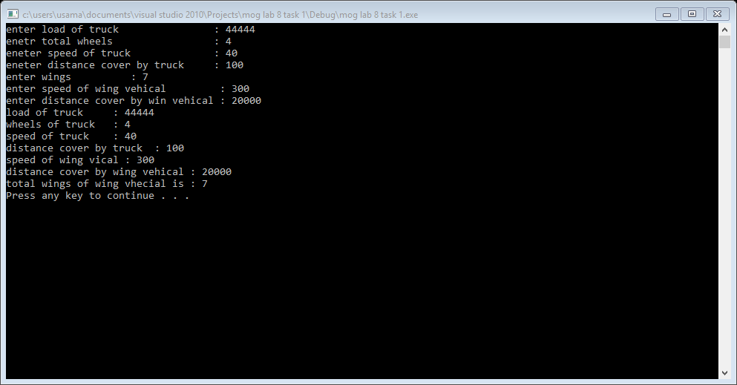

Task 2:

#include<iostream>

#include<string>

using namespace std;

class customerdata

{

private:

string name;

int no;

string addres;

string mail;

public:

void setname(string n)

{

name=n;

}

void setno(int n)

{

no=n;

}

void setaddres(string add)

{

addres=add;

}

void setmail(string m)

{

mail=m;

}

string getaddres()

{

return addres;

}

string getmail()

{

return mail;

}

string getname()

{

return name;

}

int getno()

{

return no;

}

};

class preferred_customer : public customerdata

{

private:

double pamount;

double dlevel;

public:

void setpamount(double p)

{

pamount=p;

}

void setdlevel(double d)

{

dlevel=d;

}

double getpamount()

{

return pamount;

}

double getdleve()

{

return dlevel;

}

}p;

int main()

{

int pamount;

int no;

string mail;

string name;

string add;

cout<<"enter your name : ";

cin>>name;

p.setname(name);

cout<<"enter your number : ";

cin>>no;

p.setno(no);

cout<<"enter your mail : ";

cin>>mail;

p.setmail(mail);

cout<<"enter your address : ";

cin>>add;

p.setaddres(add);

cout<<"enter purchase amount : ";

do

{

cin>>pamount;

if(pamount<0)

{

cout<<" negative value not allowed again enter "<<endl;

}

}

while(pamount<0);

p.setpamount(pamount);

if( p.getpamount()>=2000)

{

p.setdlevel(10);

}

else if(p.getpamount()>=1500)

{

p.setdlevel(7);

}

else if(p.getpamount()>=1000)

{

p.setdlevel(6);

}

else if(p.getpamount()>=500)

{

p.setdlevel(5);

}

else

{

cout<<"invalid paurchase amount "<<endl;

}

cout<<"your name is : "<<p.getname()<<endl;

cout<<"your number is : "<<p.getno()<<endl;

cout<<"your mail is :"<<p.getmail()<<endl;

cout<<"your address is :"<<p.getaddres()<<endl;

cout<<"you get discount : "<<p.getdleve()<<endl;

system("pause");

return 0;

}

Result:

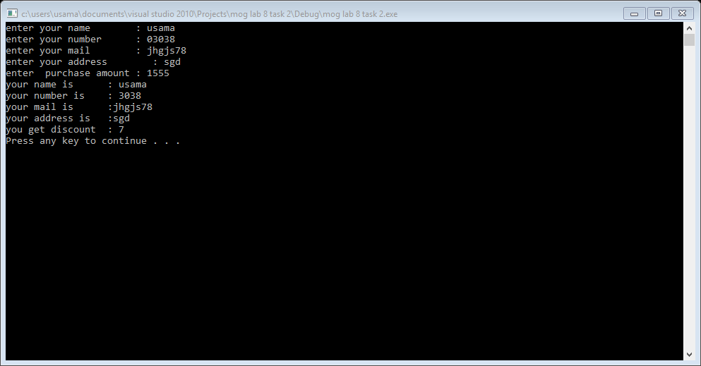

Task 4:

#include<iostream>

#include<string>

using namespace std;

class student

{

private:

string sid;

string sname;

public:

student():sid(""),sname("")

{}

student(int id, string n)

{

sid=id;

sname=n;

}

void setsid(string s)

{

sid=s;

}

void setsname(string n)

{

sname=n;

}

void getdata()

{

cout<<"enter student id : ";

cin>>this->sid;

cout<<"enter student name :";

cin>>this->sname;

}

void showsdata()const

{

cout<<endl<<"student id is : "<<this->sid<<endl;

cout<<"student name is :"<<this->sname<<endl;

}

~student()

{

cout<<"i am destructor of student class"<<endl;

}

};

class department

{

private:

string dname;

public:

department():dname("")

{}

department(string n)

{

dname=n;

}

void setdname(string d)

{

dname=d;

}

void getdata()

{

cout<<"enter department name :";

cin>>this->dname;

}

void showdata()const

{

cout<<"department name : "<<this->dname<<endl;

}

~department()

{

cout<<"i am destructor of department class"<<endl;

}

};

class course

{

private:

string courseid;

student stdobj;

department dobj;

public:

course()

{

courseid=" ";

stdobj.setsid(" ");

stdobj.setsname(" ");

dobj.setdname(" ");

}

course(string con,string stdid,string stdn,string dpn)

{

courseid=con;

stdobj.setsid(stdid);

stdobj.setsname(stdn);

dobj.setdname(dpn);

}

void getdata()

{

cout<<"enter course id : ";

cin>>courseid;

stdobj.getdata();

dobj.getdata();

}

void showdata()

{

cout<<"name of course : "<<courseid;

stdobj.showsdata();

dobj.showdata();

}

~course()

{

cout<<"i am destructor of course class"<<endl;

}

};

int main()

{

{

string cname,dname,stdid,stdname;

cout<<"enter student name : ";

cin>>stdname;

cout<<"enter student id : ";

cin>>stdid;

cout<<"enter course name : ";

cin>>cname;

cout<<"enter department name : ";

cin>>dname;

course c1(cname,stdid,stdname,dname);

cout<<"data of c1 obj"<<endl;

c1.showdata();

/*course c2;

cout<<"data of c2 object "<<endl; //c2 use default constructor and show null data

c2.showdata();*/

course c3;

cout<<"data enter for c3 obj"<<endl;

c3.getdata();

cout<<"data of c3 obj"<<endl;

c3.showdata();

cout<<endl<<endl;

}

system("pause");

return 0;

}

Result:

